Directions to Thurman Francis
712 Hazelwood Dr., Smyrna, TN 37167

From the North (Nashville):
-Take I-24E towards Chattanooga
-Take exit 66B for Sam Ridley Pkwy/TN-266 E toward Smyrna
-Merge onto TN-266 N/Sam Ridley Pkwy W – travel 1.5 miles
-Turn right onto Old Nashville Hwy – travel 1.5 miles
-Turn left onto Todd Ln – travel .6 miles
-The soccer field will be on your left

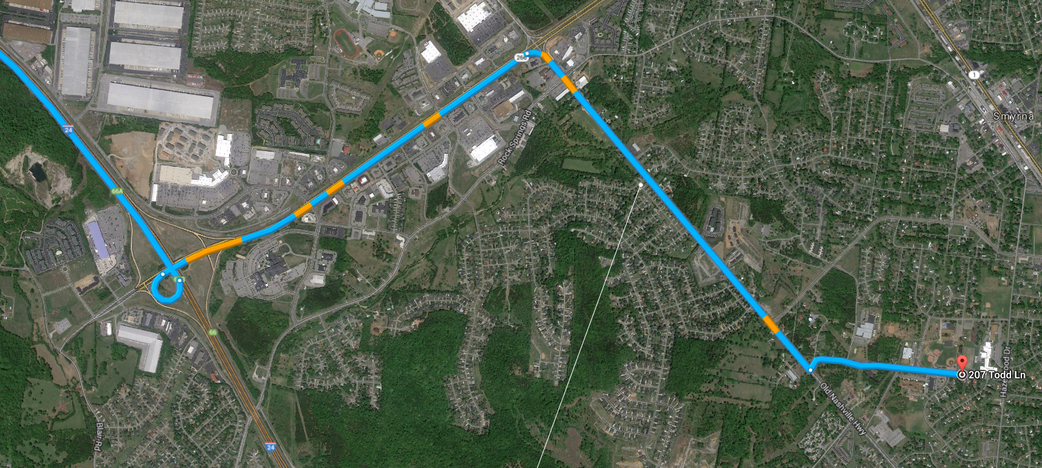

From the South (Murfreesboro):
-Take I-24 north to exit 70 for Almaville Road/TN 102 toward Smyrna
-Turn right onto Almaville Rd – travel .2 miles
-Continue onto Lee Victory Pkwy – travel 1.5 miles
-Slight right toward Old Nashville Hwy – travel .2 miles
-Take the 1st right onto Old Nashville Hwy – travel .6 miles
-Take the 3rd right onto Hazelwood Dr – travel .7 miles
-Turn left onto Todd Ln – travel .2 miles
-The soccer field will be on your right

