Directions to Pope John Paul II High School
117 Caldwell Dr
Hendersonville, TN

From Nashville on I-65 (south):
-Take exit 95 on Vietnam Veterans Blvd (TN 386N) - travel 2.5 miles
-Take exit 2 on Center Point Road and turn left – travel .2 miles
-Take 2nd left onto Caldwell Drive – travel .3 miles
-Take 1st left onto Linden Dr – travel .2 miles
-Take the first left after the tennis courts
-Follow the parking lot around to the back of the school

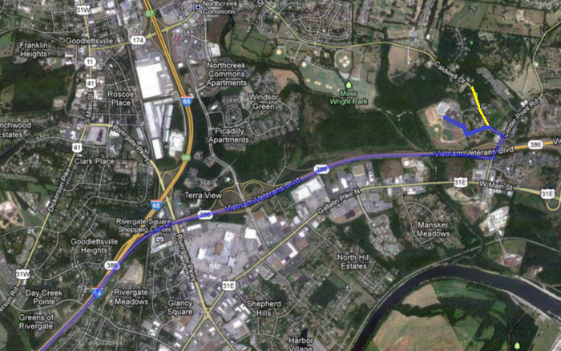

From North of Goodlettsville on I-65 (north):
-Take exit 97 on Long Hollow Pike and turn left – travel 1.1 miles
-Turn right onto Caldwell Drive – travel 2.1 miles
-Turn right onto Linden Dr – travel .2 miles
-Take the first right after the high school
-Follow the parking lot around to the back of the school

